Dr. Reevesinator GoogleHappy Status Report

4/13/20

**TESTS**

Test 11: Hashmapping

Test 12: Team setting

Test 13: Hashmapping to ID

Test 14: Hashmapping to ID 2

Test 15: Hashmapping with letters

Test 16: Inputstring

Test 17: Inputstring with prefs

Test 18: Inputstring with prefs and no input

Test 19: Inputstring with team size testing

Test 20: Multi-Char input strings

**RELEASE WALL**

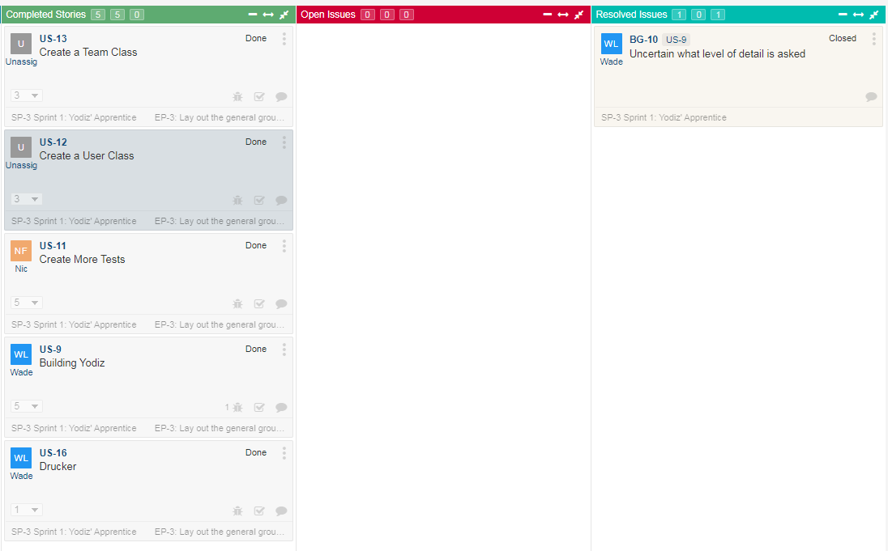

**STORYBOARD**

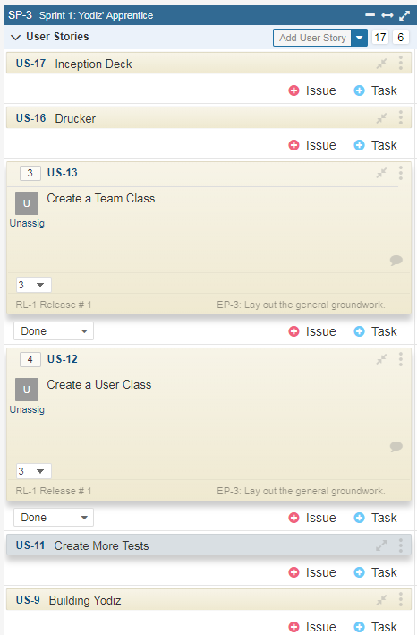

**CONTRIBUTION**

Ben: 45%

Nicolas: 40%

Wade: 15%

**UPDATED THINGS**

Users are now placed into teams based on an input option provided by the user.